<https://www.youtube.com/watch?v=mzPoUjQC4WU&list=PLHRLZtgrF2jl8yqucJsMFqh5XpRLTgCI4>

* every step things will be checked by sensers and other organization
* 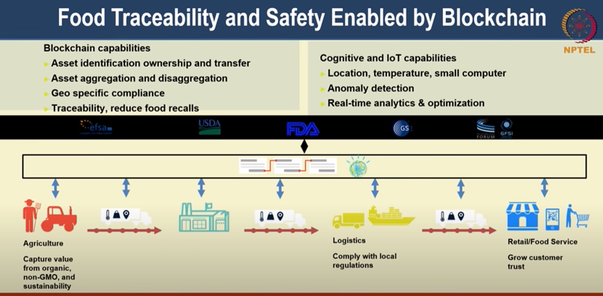
* 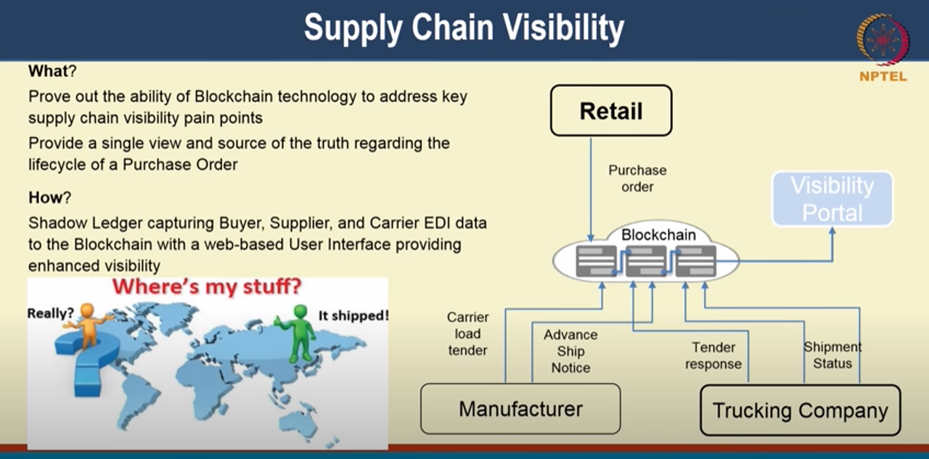
* it can also be intermers of susteneable production. you can not over using the soil, water in your area etc… depleting water…

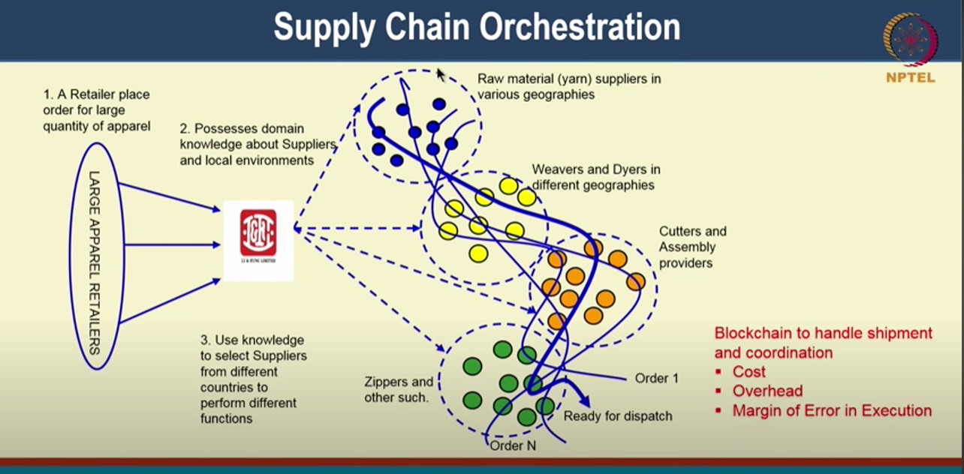

****

<https://www.youtube.com/watch?v=6ImFBrRuGG0>

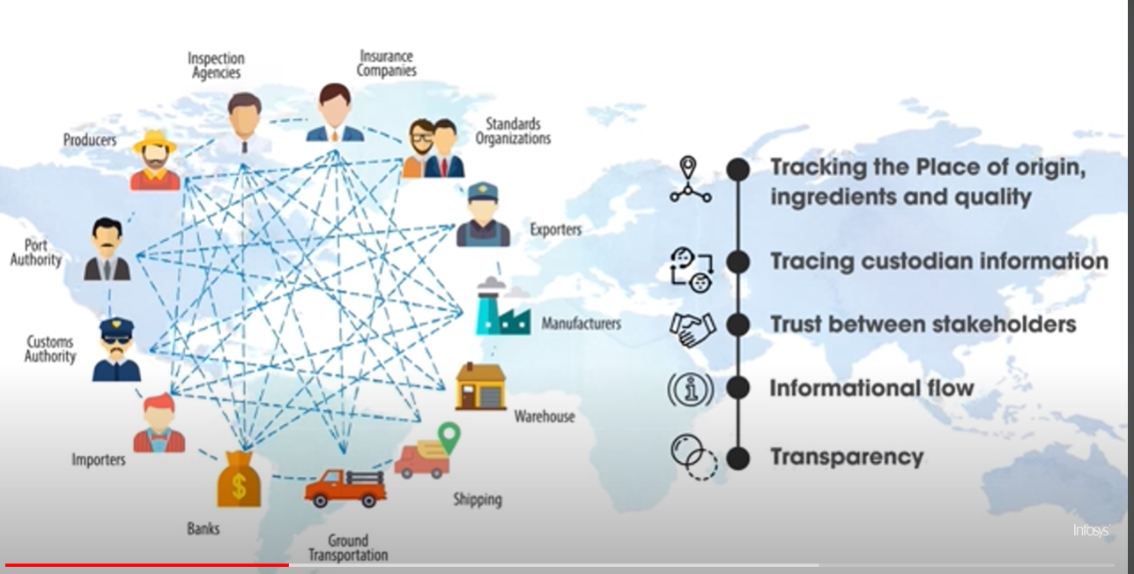

<https://www.youtube.com/watch?v=r0pv7e1oLPo>

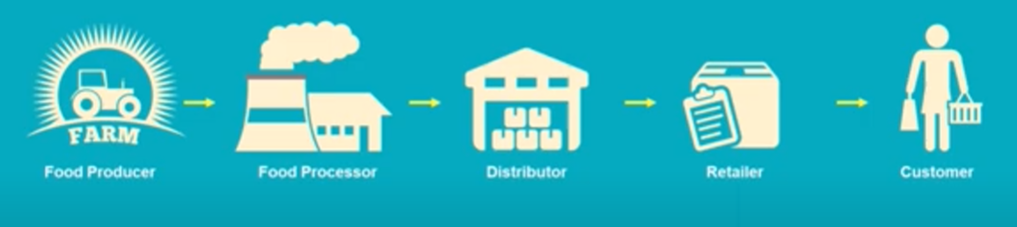

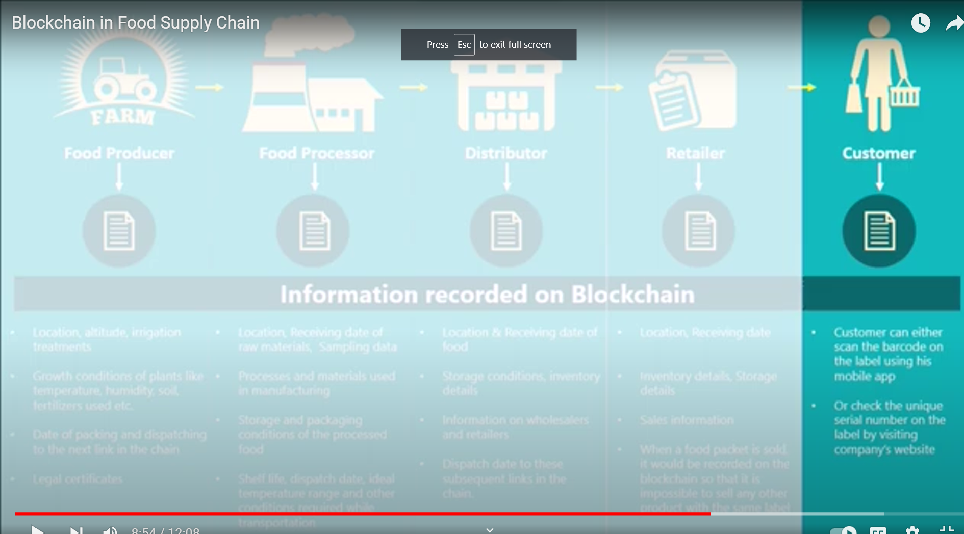

<https://www.youtube.com/watch?v=1ctigfy15Hw>

for names of item with examples

<https://www.youtube.com/watch?v=55aTGNx5vug>

project:-

<https://www.youtube.com/watch?v=Z6HS1bSZzHk>

<https://github.com/syncfab/smartcontract>

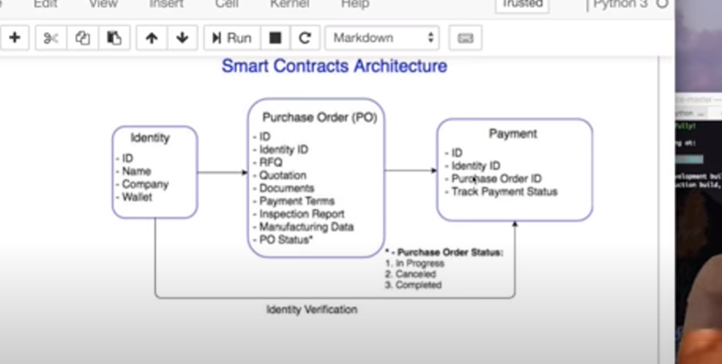

<https://www.youtube.com/watch?v=cg0p8oLZgT4>

used as :-

* end to end trace ability of supply chain
  + food traceability / organic food
    - peple can be sure that the food has came from where they are saying it came from
  + provenance
  + we can use iot data to measure these things (tempratre for cold chain etcc)

it is really a cost saving prospective the blockchain is used

biggest pain point in supply chain management:

* document
  + if I am transfring from india to us then a lot of documents I have to manage
  + solution
    - we can digitize these document and them save them in a certral storage where every party has access to same set of doucments. it will be true digitization of document
* Float
  + Supply chain float refers to all the time lags in the supply chain - potentially impacting liquidity and finance costs - whether arising from the banking system or from other sources, including the physical supply chain
  + Solution
    - we can reduce float. and make transaction faster

What we actually need:

* consensus mechanism:
  + that can bring primession less system in priissioned system

source: https://www.youtube.com/watch?v=jMihd-gqb6I

Read more: <https://www.tradelens.com/>

application of blockchain in supplychain:--

* a reastorent:-
  + they need to track the row material quality and from where is came from
  + it will save time, make more effective and payment issue solved

source: -- <https://www.youtube.com/watch?v=jMihd-gqb6I>

the conlex web of realtionshoips that provide the materials, manufacture the components, assemble the parts and devliver to market is supplychain.

s

* + Lets say you want have purchased a laptop. and you want to know its parts details and working condition in which it is assembled. or concred about quality of part
  + not only consumer but companies are also concer about knowing every part cam from and in what condition

Solution

* every componets or part will have enry on blockchain that gets tracked overtime
* user can see by date that when this part was where?
* companies can update these info real time

End result:-

* when you receive your computer you can track back about every information
* form components to row material
* single source of truth
  + manage risk
  + ensure quality of parts and product
  + track the status
  + make payment smooth
    - Chip suppler can be paid immediately when chip is test and not paid for damaged chips. and then return damaged chips and track them
    - it will reduces the large invoices and back and foutch the refund requests for faulty components
  + transparency

Source: <https://www.youtube.com/watch?v=C8ow4b5YCQU>

source:-

https://www.youtube.com/watch?v=8Ee_OhLKv6E

information after scaning qr code:--

* manufacture details
* sold from factory
* sold from vander
* expiredate

track information

* vechal type and number
* current location
* progress
* driver contact